**Instructions of Finding Your Student’s ID**

*(The student ID is used for the Scantron Achievement Series and the Scantron Performance Series assessments.)*

1. **Sign on to your On-line School.**
2. **Go to “My Info”.**

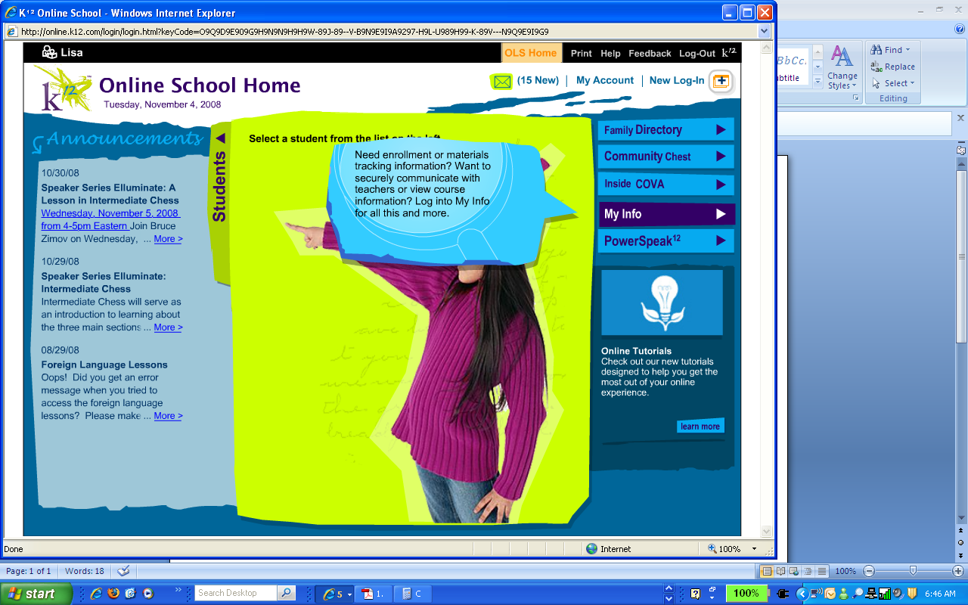

1. **Click on your student’s name.**

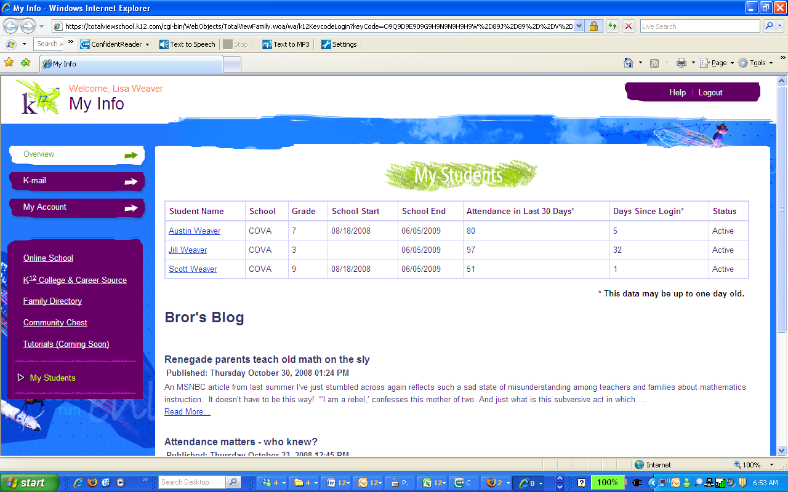

1. **Find your student ID.**

